Northeast Nebraska Public Health Department
Promoting physical and mental health and preventing disease, injury and disability in Cedar, Dixon, Thurston and Wayne Counties.
Legal Assistance
Organization | Address | City | Phone | Comments
Legal Aid of Nebraska | 214 N. 7th St. Suite 10 | Norfolk, NE | 402-644-4761  800-672-8319 (Toll Free) | Social Security Benefits, Disabilities Benefits, Veterans Benefits, Earned Income Tax Credit, Bankruptcy, House Evictions, Landlord/ Tenant, Foreclosures, Child Advocacy, Child Support, Divorce. Many other services available. See link below.  www.legalaidofnebraska.org/how-we-help/call-for-help/
 | 941 “O” St.  Suite 325 | Lincoln, NE | 402-435-2161  800-742-7555 (Toll Free)
 | 209 S. 19th St. Suite 200 | Omaha, NE | 402-348-1069  888-991-9921 (Toll Free)
Native American Access Line |  |  | 1-800-729-9908 | Family Law, Juvenile Law, Criminal Law, Tribal Education, Tribal Collectsion & Garnishments.  www.legalaidofnebraska.org/how-we-help/programs-and-projects/native-american/
Disability Rights Nebraska | 134 S. 13th St Suite 600 | Lincoln, NE | 402-474-3183  800-422-6691 (Toll Free)  info@disabilityrightsnebraska.org | Offers legal representation and advocacy to people with disabilities and their families  www.disabilityrightsnebraska.org/
Protect the Good Life | 2115 State Capitol | Lincoln, NE | 402-471-2682  800-727-6423 (Toll Free)  888-850-7555 (Spanish)  888-287-0778 (Senior) | Provides consumer education, mediation of consumer complaints, and enforcement.  protectthegoodlife.nebraska.gov/
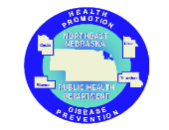

Caring Connections Coalition: Resource Directory first developed in 2009 for the Caring Connections Coalition. Last updated December 2021.
Northeast Nebraska Public Health Department does not endorse or accept responsibility or liability for any services provided by any of the organizations listed.

Organization | Address | City | Phone | Comments
Nebraska Department of Health and Human Services- Child Support Enforcement | 301 Centennial Mall S. | Lincoln, NE | 877-631-9973  Option 2 | Provide parents assistance with financial support and medical insurance coverage for children.  https://dhhs.ne.gov/Pages/child-support.aspx
Nebraska Mediation Center | 435 North Park Ave | Fremont, NE | 402-753-9415 | http://nebraskamediationcenter.com  nmc@nebraskamediationcenter.com

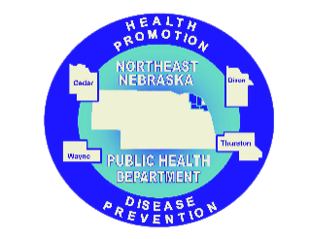

Caring Connections Coalition: Resource Directory first developed in 2009 for the Caring Connections Coalition. Last updated December 2021.
Northeast Nebraska Public Health Department does not endorse or accept responsibility or liability for any services provided by any of the organizations listed.

