Northeast Nebraska Public Health Department
Promoting physical and mental health and preventing disease, injury and disability in Cedar, Dixon, Thurston and Wayne Counties.
Health & Wellness Assistance – Low Cost Clinics
Organization | Address | City | Phone | Comments
Charles Drew Health Center | 2915 Grant St. | Omaha | 402-451-3553 | Accepts Medicaid & Medicare. Spanish speaking services available.
Good Neighbor Community Health Center | 4321 41st Ave  2740 N. Clarkson St. | Columbus  Fremont | 402-562-7500  402-721-0951 | Accepts Medicaid & Medicare. Spanish speaking services available.
Midtown Health Center | 302 W. Phillip Ave. | Norfolk | 402-371-8000 | Accepts Medicaid & Medicare. Spanish speaking services available.
One World Community Health Center | 402-734-4110 | Omaha | 402-734-4110 | Accepts Medicaid & Medicare. Spanish speaking services available.
Bluestem Health | 1021 N. 27th St. | Lincoln | 402-476-1455 | Spanish Speaking Staff Available
Siouxland Community Health Center | 1021 Nebraska St. | Sioux City, IA | 712-252-2477 | Accepts Medicaid & Medicare. Spanish speaking services available.
Northeast Nebraska Community Action Partnership | 603 Earl St. | Pender | 402-385-6300 | Wayne, Dixon, Thurston, Cedar County Residents. Spanish speaking services available. https://nencap.org/services/
Nebraska Tobacco Quitline |  | English  Spanish | 800-784-8669  855-335-3569 | www.quitnow.net
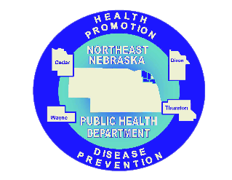

Caring Connections Coalition: Resource Directory first developed in 2009 for the Caring Connections Coalition. Last updated December 2021.
Northeast Nebraska Public Health Department does not endorse or accept responsibility or liability for any services provided by any of the organizations listed.

