Northeast Nebraska Public Health Department
Promoting physical and mental health and preventing disease, injury and disability in Cedar, Dixon, Thurston and Wayne Counties.
Clothing & Household Items Discount Stores
Organization | Address | City | Phone | Comments
Micah’s Closet | 602 Main Street | Wayne, NE | 402-375-2231
First Presbyterian Church | 216 W 3rd St. | Wayne, NE | 402-375-2669
Wakefield Nearly New | 303 Main St. | Wakefield, NE | 402-287-8700
Goodwill of the Plains | 1804 Center Dr. | Norfolk, NE | 402-371-6275
Goodwill of the Plains | 2321 Dakota Ave. | South Sioux City, NE | 402-494-6972 | Spanish Speaking Staff Available
Salvation Army Thrift Store | 610 W. Norfolk St. | Norfolk, NE | 402-379-4663
Salvation Army Thrift Store | 1901 Cornhusker Dr. | South Sioux City, NE | 402-494-7997
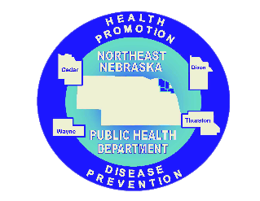

Caring Connections Coalition: Resource Directory first developed in 2009 for the Caring Connections Coalition. Last updated December 2021.
Northeast Nebraska Public Health Department does not endorse or accept responsibility or liability for any services provided by any of the organizations listed.

