Northeast Nebraska Public Health Department
Promoting physical and mental health and preventing disease, injury and disability in Cedar, Dixon, Thurston and Wayne Counties.
GED & ESL
Organization | Address | City | Phone | Email
Northeast Community College (Adult Education) | 801 E Benjamin Ave.  MaClay Building Room 180 | Norfolk, NE | 402-844-7255  OR  402-844-7256 | adulteducation@northeast.edu
 | 1001 College Way | South Sioux City, NE | 402-241-6415 | adulteducation@northeast.edu

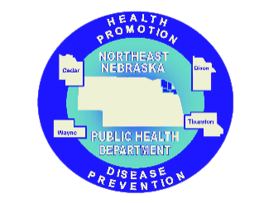

Caring Connections Coalition: Resource Directory first developed in 2009 for the Caring Connections Coalition. Last updated December 2021.
Northeast Nebraska Public Health Department does not endorse or accept responsibility or liability for any services provided by any of the organizations listed.

