Northeast Nebraska Public Health Department
Promoting physical and mental health and preventing disease, injury and disability in Cedar, Dixon, Thurston and Wayne Counties.
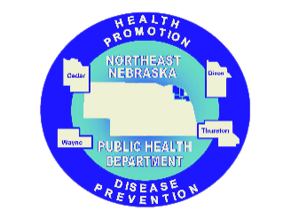
Food Assistance
Organization | Address | City | Phone | Comments
Northeast Nebraska Community Action Partnership (NENCAP) | 603 Earl St. | Pender, NE | 402-385-6300 | Serves: Wayne, Dixon, Thurston, and Cedar County Residents. Spanish Speaking Staff Available at Clinic.  https://nencap.org/services/
City of Hartington - Food Pantry | 107 W. State St. | Hartington, NE | 402-254-6353 | Serves: Cedar County Residents
St. John’s Lutheran Church | 310 W. Broadway St. | Randolph, NE | 402-337-0414 | Serves: Randolph and Surrounding Area Residents
Salem Lutheran Church | 411 Winter St. | Wakefield, NE | 402-287-2681 | Serves: Wakefield and Emerson Residents.
First Presbyterian Church | 216 W. 3rd St. | Wayne, NE | 402-375-2669 | Serves: Wayne County Residents  Open Tuesday-Friday 9 AM- 12 PM
Wayne Mobile Food Bank | 421 N. Pearl Street | Wayne, NE | 402-375-2231 (First United Methodist Church for More Information) | Last Saturday of Each Month from 9:30AM- 11:00 AM at Our Savior Lutheran Church
Supplemental Nutrition Assistance Program (SNAP) |  |  | 800-221-5689 | Helps eligible low-income individuals and families buy food. https://dhhs.ne.gov/Pages/SNAP.aspx

Caring Connections Coalition: Resource Directory first developed in 2009 for the Caring Connections Coalition. Last updated December 2021.
Northeast Nebraska Public Health Department does not endorse or accept responsibility or liability for any services provided by any of the organizations listed.

