Northeast Nebraska Public Health Department
Promoting physical and mental health and preventing disease, injury and disability in Cedar, Dixon, Thurston and Wayne Counties.
Organization | Phone | Website | Coverage | Service
Northeast Nebraska Community Action Partnership | 402-385-6300 | https://www.nencap.org/services/healthy-families/ | Cedar, Dixon, Thurston, Wayne, & Other Northeast Nebraska Counties | Home visits, individualized information and referrals for resources and designed to meet family’s specific parenting needs.
Nebraska Family Helpline | 888-866-8660 | https://dhhs.ne.gov/Pages/Nebraska-Family-Helpline.aspx | Statewide | Free resource for parents with kids of all ages with question regarding their child’s behavior.
Boys Town National Hotline | 800-448-3000  (Crisis Hotline)  531-355-3500  (Behavioral Health Services)  402-734-0155  (Bilingual Services) | https://www.boystown.org | National | Spanish speaking counselors available along with translation services for more than 140 languages.
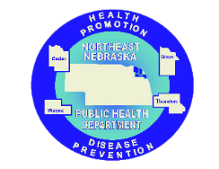
Parenting Support

Caring Connections Coalition: Resource Directory first developed in 2009 for the Caring Connections Coalition. Last updated December 2021.
Northeast Nebraska Public Health Department does not endorse or accept responsibility or liability for any services provided by any of the organizations listed.
Organization | Address | Website | Coverage | Comments
MOPS | 888-910-6677 (Toll Free) | http://www.mops.org/ | National | Mother support group.  info@mops.org
Good Life Counseling & Support | 402-371-3044 | http://goodlifecounseling.com/?page_id=28 | Nebraska | Offers parenting classes.
Answers4Families | 800-746-8420 | https://www.answers4families.org/ | Nebraska | Provides training & information to provide bimonthly webinars over a range of topics about children & youth with disabilities & their families.
Lutheran Family Services | 800-267-9876  402-661-7100  (Omaha Children’s Services Center) | https://www.lfsneb.org/service/centers-for-healthy-families/ | Nebraska, Kansas, Iowa | Provide support for children, communities, & behavioral health for people of all ages.
National Cooperative Extension System – Parenting Resources |  | https://nifa.usda.gov/program/child-and-family-development | National | Resource for research-based information
National Cooperative Extension System |  | https://jitp.info/ | National | Parenting eNewsletters
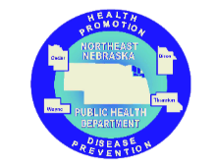

Caring Connections Coalition: Resource Directory first developed in 2009 for the Caring Connections Coalition. Last updated December 2021.
Northeast Nebraska Public Health Department does not endorse or accept responsibility or liability for any services provided by any of the organizations listed

