Northeast Nebraska Public Health Department
Promoting physical and mental health and preventing disease, injury and disability in Cedar, Dixon, Thurston and Wayne Counties.
Financial Resources
Organization | Phone | Services | Website
Nebraska Department of Health and Human Resources- ACCESS Nebraska | 800-383-4278 (Economic Assistance)  855-632-7633 (Medicaid Eligibility) | Administers and manages eligibility for Medicaid and Economic Assistance programs. Spanish services available. | www.accessnebraska.ne.gov
Supplemental Security Income | 1-800-722-1213 (Toll Free Available 24/7)  1-800-325-0778 (Toll Free TTY for the hard of hearing or deaf) | Help aged, blind, and disabled people who have little or no income and provides cash for basic needs for food, clothing, and shelter. Spanish services available. | https://www.ssa.gov/ssi/
Nebraska Senior Health Insurance Information Program (SHIP) | 1-800-234-7119 | Educate older people and people with disabilities of their health insurance or Medicare and raise awareness of health care fraud. Spanish services available. | https://doi.nebraska.gov/consumer/senior-health
Veterans Administration | 1-800-698-2411  1-800-273-8255, Press 1, (Veterans Crisis Line) | Financial Counseling, Career Center, Educational & Vocational Counseling, Fiduciary Program, Independent Living, Mortgage Delinquency Assistance, VetSuccess on Campus. Spanish services available. | https://www.va.gov/

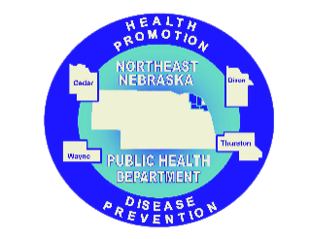

Caring Connections Coalition: Resource Directory first developed in 2009 for the Caring Connections Coalition. Last updated December 2021.
Northeast Nebraska Public Health Department does not endorse or accept responsibility or liability for any services provided by any of the organizations listed.

