Northeast Nebraska Public Health Department
Promoting physical and mental health and preventing disease, injury and disability in Cedar, Dixon, Thurston and Wayne Counties.
Transportation
Organization | City | Phone | Comments
Cedar County Transit | Hartington, NE | 402-640-6147 | https://co.cedar.ne.us/pdfs/Cedar_County_Transit_System_info_sheet.pdf
Wakefield Public Transportation Program | Wakefield, NE | 402-287-2149 | Pick-Up at Gardner Senior Center (320 Johnson St. Wakefield, NE)
Wayne Public Transportation | Wayne, NE | 402-375-1460 | https://www.cityofwayne.org/137/Handi-Van
Ponca Express Rural & Metro | Norfolk & Niobrara  Metro Area (Omaha, Lincoln, Sioux City, IA) | 877-769-3111  402-438-9224 | https://www.poncatribe-ne.org/services/ponca-express/

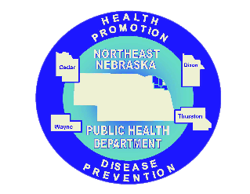

Caring Connections Coalition: Resource Directory first developed in 2009 for the Caring Connections Coalition. Last updated December 2021.
Northeast Nebraska Public Health Department does not endorse or accept responsibility or liability for any services provided by any of the organizations listed.

