Northeast Nebraska Public Health Department
Promoting physical and mental health and preventing disease, injury and disability in Cedar, Dixon, Thurston and Wayne Counties.
Homeless Shelters
Organization | Address | City | Phone | Comments
Open Door Mission | 2828 N. 23rd St. E. | Omaha, NE | 402-422-1111
Siena Francis House | 1702 Nicholas St. | Omaha, NE | 402-341-1821 | Spanish Speaking Staff Available
Stephen’s Center | Shelter: 2723 Q St.  Permanent Housing | Omaha, NE  Omaha, NE | 402-715-5471  402-715-5442
Care Corps’ LifeHouse | 723 N. Broad St. | Fremont, NE | 402-721-3125 | Spanish Services Available
Norfolk Rescue Mission | 111 N. 9th St. | Norfolk, NE | 402-371-6484 | Spanish Speaking Staff Available
People’s City Mission | 110 Q St. | Lincoln, NE | 402-475-1303 | Spanish Speaking Staff Available
Welcome Home Family Shelter | 2700 Leech Ave. | Sioux City, IA | 712-898-4096 | Spanish Speaking Services Available
The Gospel Mission | 500 Bluff St. | Sioux City, IA | 712-255-1769

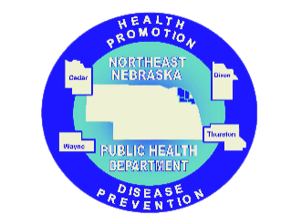

Caring Connections Coalition: Resource Directory first developed in 2009 for the Caring Connections Coalition. Last updated December 2021.
Northeast Nebraska Public Health Department does not endorse or accept responsibility or liability for any services provided by any of the organizations listed.

