Northeast Nebraska Public Health Department
Promoting physical and mental health and preventing disease, injury and disability in Cedar, Dixon, Thurston and Wayne Counties
Wildlife and Pest Management
Organization | Phone | City | Area of Coverage
Johnny’s Pest Control | 402-369-2938 | Laurel, NE | Laurel and surrounding areas.
Olson’s Pest Technicians | 800-881-8547 | Yankton, NE | Yankton & surrounding areas. Services & specializes in monthly inspections.  https://www.800kilbugs.com/
Presto-X Company | 866-881-8547 | Across NE | Year-round pest control & pest protection in neighborhoods & residential areas.  https://www.prestox.com/
Stetson Wildlife Management | 402-476-6663 | Lincoln, NE | Eastern Nebraska
All Pro Pest Management | 712-277-2755 | Sioux City, IA | Sioux City and surrounding areas.  https://heybugguy.com/home/
Orkin Inc | 877-452-2808  402-983-8172  402-915-0160  712-717-7734 | Toll Free  Lincoln, NE  Omaha, NE  N. Sioux City, SD | National
Raptor Recovery Center | 866-888-7261 | Eagle, NE | State of Nebraska
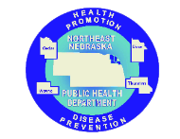

Caring Connections Coalition: Resource Directory first developed in 2009 for the Caring Connections Coalition. Last updated December 2021.
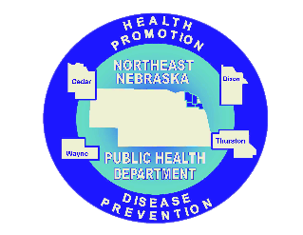
Northeast Nebraska Public Health Department does not endorse or accept responsibility or liability for any services provided by any of the organizations listed.

