Northeast Nebraska Public Health Department
Promoting physical and mental health and preventing disease, injury and disability in Cedar, Dixon, Thurston and Wayne Counties.
Veteran’s Resources
Organization | Address | City | Phone | Comments
VA Clinic | 3204 Raasch Dr.  4101 Woolworth Ave. | Norfolk, NE  Omaha, NE  Mental Health | 402-370-4570  800-608-8806  402-346-8800  402-346-8800 | Interpretation: 800-698-2411 Option 1
Legal Aid of Nebraska | 214 N. 7th St.  Suite 10 | Norfolk, NE | 402-644-4761
Veterans Crisis Line |  | National | 1-800-273-8255 | Press 1
Military One Source |  | National  Spanish | 800-342-9647  800-342-9647 | https://www.militaryonesource.mil/
Vets 4 Warriors |  | National | 855-838-8255 | https://www.vets4warriors.com/
Benefits.gov |  |  |  | https://www.benefits.gov/benefits/browse-by-category/category/30
Network of Care |  |  |  | https://region4.ne.networkofcare.org/mh/services/category.aspx?cid=25398
Center for Rural Affairs |  |  |  | https://www.cfra.org/veteran-farmers
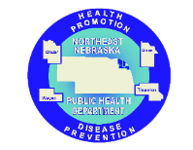

Caring Connections Coalition: Resource Directory first developed in 2009 for the Caring Connections Coalition. Last updated December 2021.
Northeast Nebraska Public Health Department does not endorse or accept responsibility or liability for any services provided by any of the organizations listed.
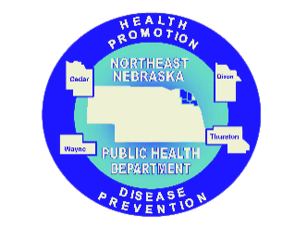
Veteran’s Service Officers by County

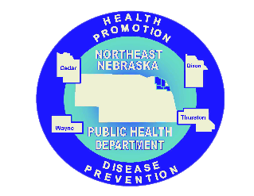

Caring Connections Coalition: Resource Directory first developed in 2009 for the Caring Connections Coalition. Last updated December 2021.
Northeast Nebraska Public Health Department does not endorse or accept responsibility or liability for any services provided by any of the organizations listed.
County | Name | Email | Phone | Fax | City
Cedar | Scott Stanton | veterans@hartel.net | 402-254-7473 | 402-254-7173 | Hartington, NE
Dixon | Bill Johnston | bjohnston@dakotacountyne.org | 402-987-2120 | 402-949-9220 | Dakota City, NE
Thurston | Penny Warren | vso@thurston.nacone.org | 402-385-3199 |  | Pender, NE
Wayne | Bradlye Wieland | vso@wayne.nacone.org | 402-375-2764 | 402-375-0103 | Wayne, NE

