Northeast Nebraska Public Health Department
Promoting physical and mental health and preventing disease, injury and disability in Cedar, Dixon, Thurston and Wayne Counties.
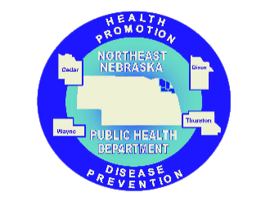
Domestic Violence/Sexual Assault
Organization | Phone | Coverage | Services | Website
Haven House Family Services Center | 402-375-5433 (Wayne Office)  800-440-4633 (24 Hour Crisis Line) | Wayne, Cedar, Thurston, Dixon & Dakota Counties, Winnebago & Omaha Reservations | Offers intervention and prevention services for survivors of domestic violence and sexual assault. Spanish Speaking Staff Available | http://havenhousefsc.com/
Nebraska Coalition to End Sexual and Domestic Violence | 402-476-6256 (Lincoln Office)  1-877-215-0167- (Nebraska Spanish Helpline)  1-800-656-4673 (Rape & Abuse National Network) | Statewide | Legal Referrals & Assistance with Protection Orders, Emergency Shelters, Ongoing Support, Transportation to Safe Places, Education & Prevention Programs, and Medical Advocacy Referrals. Spanish Speaking Staff Available | http://www.nebraskacoalition.org/
National Domestic Violence Hotline | 1-800-799-7233 | National | Confidential, one-on-one support, crisis intervention, next step options, and direct connection to sources for immediate safety. Spanish speaking services available. | https://www.thehotline.org/

Caring Connections Coalition: Resource Directory first developed in 2009 for the Caring Connections Coalition. Last updated December 2021.
Northeast Nebraska Public Health Department does not endorse or accept responsibility or liability for any services provided by any of the organizations listed.
Organization | Phone | Coverage | Services | Website
National Teen Dating Abuse Helpline | 1-866-331-9474  TEXT: LOVEIS to 22522 | National | Support, information, and advocacy to young people who have questions/ concerns about their dating relationships. Spanish speaking services available. | http://www.loveisrespect.org/
The Northeast Child Advocacy Center (NENCAC) | 402-644-7402 (O’Neill Office)  402-371-4880 (Norfolk Office)  800-652-1999  (NE Child Abuse  Hotline) | Northeast Nebraska | Professionals from Law Enforcement, Health & Human Services, and other agencies come together, discuss, and decided what the next steps are in child abuse investigations | http://frhs.org/our-services/directory/child-advocacy-center
Domestic Violence Safe Options Services (S.O.S) | 605-624-5311 | Clay, Union, and Turner Counties in Southeast South Dakota | Emergency Crisis Counseling, Food Assistance, Shelter, Transportation Assistance, and other On-Demand Resources | http://dvsos.org/
Council on Sexual Assault and Domestic Violence | 712-258-7233 (Sioux City Office)  1-800-982-7233 (24/7 Crisis Hotline) | Service for Iowa Residents | Spanish services available. | https://safeplacesiouxland.org/
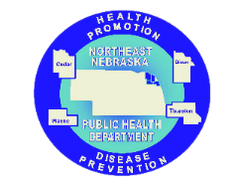

Caring Connections Coalition: Resource Directory first developed in 2009 for the Caring Connections Coalition. Last updated December 2021.
Northeast Nebraska Public Health Department does not endorse or accept responsibility or liability for any services provided by any of the organizations listed.

