Northeast Nebraska Public Health Department
Promoting physical and mental health and preventing disease, injury and disability in Cedar, Dixon, Thurston and Wayne Counties.
Hospitals
Organization | Address | City | Phone | Comments
Pender Community Hospital | 100 Hospital Dr. | Pender, NE | 402-385-3083 | Accepts Medicare & Medicaid. Spanish Services Available.
Providence Medical Center | 1200 Providence Road | Wayne, NE | 402-375-3800 | Accepts Medicare & Medicaid. Interpretive Services Available.
Twelve Clans Unity Hospital | 225 S. Bluff St.  PO Box HH | Winnebago, NE | 402-878-2231 | Services for Winnebago Community & Native American Patients in Region
Unity Point- St. Luke’s | 2720 Stone Park Blvd | Sioux City, IA | 712-279-3500 | Accepts Medicaid.
Mercy Medical Center | 801 5th St. | Sioux City, IA | 712-279-2010 | Accepts Medicare & Medicaid. Spanish Speaking Staff Available.
Faith Regional Health Services | 2700 W. Norfolk Ave. | Norfolk, NE | 402-371-4880 | Accepts Medicare & Medicaid. Interpreters Available.

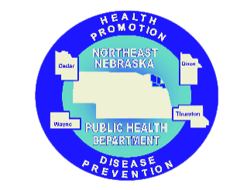

Caring Connections Coalition: Resource Directory first developed in 2009 for the Caring Connections Coalition. Last updated December 2021.
Northeast Nebraska Public Health Department does not endorse or accept responsibility or liability for any services provided by any of the organizations listed.

