Northeast Nebraska Public Health Department
Promoting physical and mental health and preventing disease, injury and disability in Cedar, Dixon, Thurston and Wayne Counties.
Organization | Address | City |  | Phone | Comments
Phillips Vision Source | 202 S. Robinson Ave. | Hartington, NE |  | 402-254-2020 | Accepts Medicaid
Authier Miller Pape Eyecare | 3610 W. Norfolk Ave | Norfolk, NE |  | 402-371-8230 | Accepts Medicaid & Medicare. Must provide own interpreters.
 | 116 E. Main Street | Pierce, NE |  | 402-329-4100 | Accepts Medicaid & Medicare.
Wayne Vision Center | 313 Main St. | Wayne, NE |  | 402-375-2020 | Accepts Medicaid & Medicare.
Magnuson-Hopkins Eyecare | 1112 W. 7th St. | Wayne, NE |  | 402-375-5160 | Accepts Medicaid. Dr. speaks little Spanish.
Walmart Vision & Glasses | 2400 W. Pasewalk Ave.  1601 Cornhusker Dr. | Norfolk, NE  South Sioux City, NE |  | 402-371-5715  402-494-1498 | Accepts Medicaid & Medicare.  Accepts Medicaid & Medicare. Spanish Speaking Staff Available.
Eye Physicians | 2501 Lakeridge Dr. | Norfolk, NE |  | 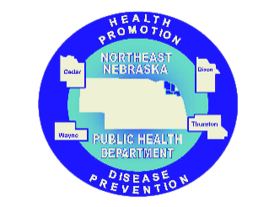  402-371-3158 | Accepts Medicaid & Medicare. Spanish Speaking Staff Available.
Eye Doctors

Caring Connections Coalition: Resource Directory first developed in 2009 for the Caring Connections Coalition. Last updated December 2021..
Northeast Nebraska Public Health Department does not endorse or accept responsibility or liability for any services provided by any of the organizations listed.

